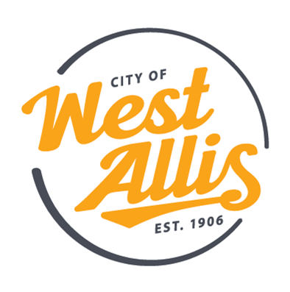
Join the City of West Allis Department of Public Works as an Equipment Mechanic and play a crucial role in keeping our community running. You’ll maintain and repair a diverse fleet of vehicles and heavy equipment that support essential city services.

Why You’ll Love This Role
- You’ll work with an impressive variety of equipment—from light-duty vehicles to heavy construction machinery.
- Every day is different, with opportunities to troubleshoot, repair, fabricate, and problem-solve.
- You’ll be part of a supportive team that values professionalism, safety, and craftsmanship.
- Your work directly impacts our community’s operations and public safety.
- Opportunities to grow your skills, obtain certifications, and work with advanced diagnostic and repair technologies.

What You’ll Do
- Conduct preventative maintenance (PM) inspections and complete necessary repairs to keep equipment operating safely and efficiently.
- Handle tire maintenance, repair, and replacement across the fleet.
- Perform skilled mechanical, technical, and diagnostic work on City vehicles and equipment.
- Maintain and repair a wide range of equipment, including cars, trucks, refuse trucks, loaders, sweepers, pumps, compressors, and other heavy construction machinery.
- Perform occasional welding, fabrication, and machine shop tasks.
- Service small engines and specialty equipment such as lawn mowers, chainsaws, snow blowers, generators, and air compressors.
- Operate and maintain seasonal equipment, including snowplows and salt spreaders.
- Complete assigned work from supervisors and ensure repairs meet quality and safety standards.
- When needed, repair Fire Department equipment, including ambulances, pumpers, rescue trucks, and ladder trucks.

What You Bring
- A valid driver’s license meets City driving standards.
- Associate’s degree with 0–2 years of experience OR 4–5 years of relevant experience without a degree.
- Willingness to obtain CDL (B, C, D with Tanker endorsement) and forklift certification within 6 months.
- Ability to work in tight spaces, in all weather conditions, and on a wide range of equipment.
  - Desired (but not required):
  - ASE Master Medium/Heavy Truck Certification
  - Experience in diagnosing and repairing engines, drivetrains, electrical systems, HVAC, suspension, hydraulics, and emissions systems
  - Welding, fabrication, and body repair experience (metal, fiberglass, or plastic)
  - Ability to assess damage and determine the best repair methods
  - Experience operating and transporting heavy equipment
  - Installation of decals, safety striping, and performing light painting and refinishing work

Why Work for Us
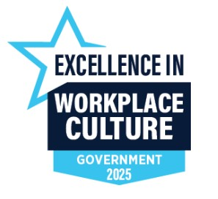
As you take care of our city, we’ll take care of you! We offer valuable benefits and perks, including:
- Health & Wellness:
  - City covers 88% of the medical premium (HRA plan).
  - FREE dental insurance.
  - FREE life insurance.
  - FREE long-term disability coverage.
- Retirement:
  - Participate in Wisconsin’s Retirement Fund with 7% city contribution.
- Generous Time Off:
  - Up to 25 days annually to start.
  - Holiday pay (up to 9 days).
- Professional Growth:
  - Paid training – we invest in our employees!
  - Tuition reimbursement.
  - Educational bonuses for certifications/training completed on city time.
  - Opportunities for advancement.
- Financial Perks:
  - Student loan repayment program.
  - Federal loan forgiveness.
  - Annual salary increases.
- Culture & Extras:
  - Paid employee recognition programs.
  - Employee wellness program.
  - Employee assistance program.
  - Pet insurance.
  - Employee events and more!
Click here to review the full job description!

